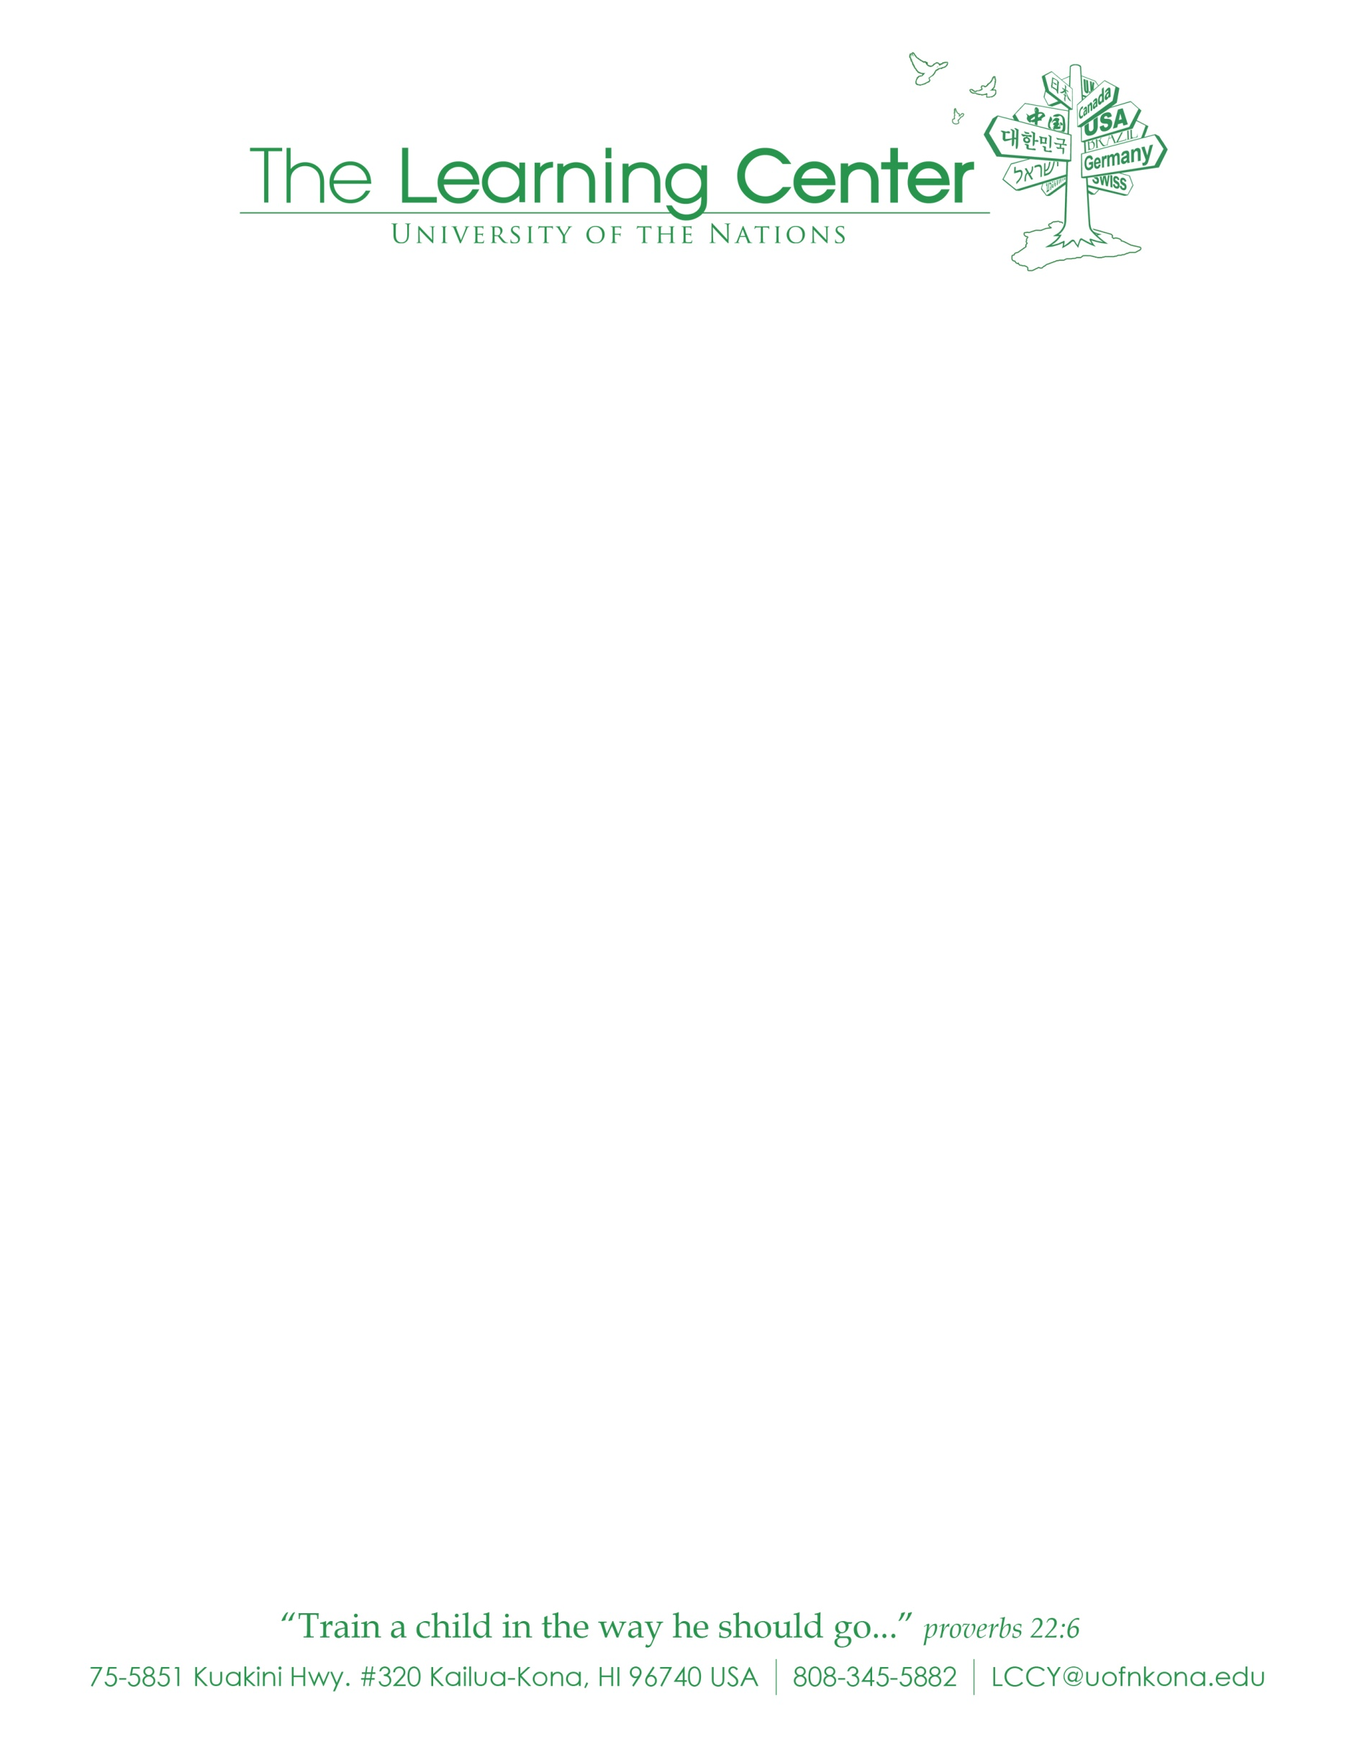

**Continued Enrollment Registration Application 2018-2019 School Year**

**Student(s) Name: Date of Birth: Grade in August 2018:**

**___________________________ ____________________ ____________________**

**___________________________ ____________________ ____________________**

**___________________________ ____________________ ____________________**

**Please Initial**:________ I have paid the annual **Registration fee of $40/child**. Checks made payable to: **ICSKHC, Inc.** (**Non-Refundable)**

________ I have read, agreed to, and signed the **2018-2019** **Tuition and** F**inancial Agreement**.

________ I have completed my child’s **Emergency Contact Information form** and all other forms required by TLC.

________ I have signed the **Chromebook Policy** Forms

________ I have submitted a copy of my child’s current **Medical Insurance Card**

________ I have submitted a copy of my child’s most recent **TB test** (if requested)

________ I commit to sign-up for **and** serve a set number of **Lunch Duties** for the year

________ I commit to sign-up for **and** serve at least **40 Parent Service Hours** for the year (**20** Hours for single parents).

________ I commit to **attend all Parent Meetings**.

________ I have provided **ALL other** requested documents to TLC.

________ I understand that **I must pay the August 2018 tuition by April 27, 2018.**

**________** My **current** 2017-2018 Tuition Balance **has been paid** and is up-to-date.

**PHOTO PERMISSION**: From time to time photographs are taken of your child (ren) for UofN and/or The Learning Center to use. Photos are not given to any other agency or person. Please indicate if you give us permission to use photos of your child. _________ Yes, I will allow my child(ren) to be photographed _________ No, I will not allow my child(ren) to be photographed

NOTE: Your child’s(ren) **continued enrollment** will **not** be confirmed **until** **all** of the above have been agreed to and/or provided to TLC.

|  |  |  |
| --- | --- | --- |
| **Parent Signature Print** |  | **Date** |
| **Parent Signature Print** |  | **Date** |

|  |
| --- |
|  |

|  |
| --- |
|  |

___

*Initial*

_____

*Initials*